Ques1 Write a program to find greatest between two numbers.

Code:

def find_greatest(num1, num2):  
 if num1 > num2:  
 return num1  
 else:  
 return num2  
  
  
# Example usage:  
num1 = int(input("Enter the first number: "))  
num2 = int(input("Enter the second number: "))  
  
greatest = find_greatest(num1, num2)  
print("The greatest number is:", greatest)

Output:

Enter the first number: 22

Enter the second number: 56

The greatest number is: 56

Snap:

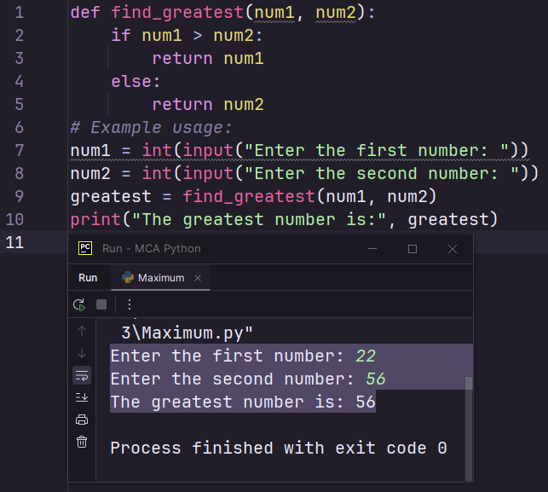

Ques-2 Write a program to Accept two Integers and Check if they are Equal

Code:

# Accept two integers from the user  
num1 = int(input("Enter the first number: "))  
num2 = int(input("Enter the second number: "))  
  
# Check if the numbers are equal  
if num1 == num2:  
 print("The numbers are equal.")  
else:  
 print("The numbers are not equal.")

Output:

Enter the first number: 25

Enter the second number: 26

The numbers are not equal.

Snap:

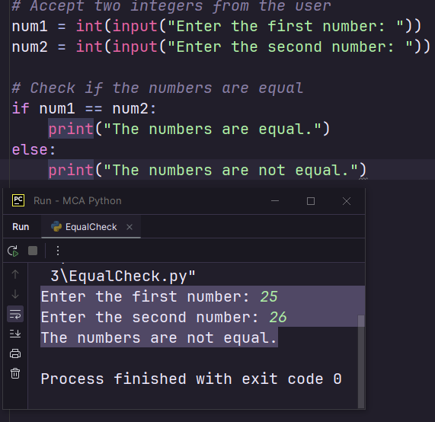

Ques-3 Write a program to Check if a given Integer is Positive or Negative.

Code:

# Accept an integer from the user  
num = int(input("Enter an integer: "))  
  
# Check if the number is positive or negative  
if num > 0:  
 print("The number is positive.")  
elif num < 0:  
 print("The number is negative.")  
else:  
 print("The number is zero.")

Output:

Enter an integer: -23

The number is negative.

Snap:

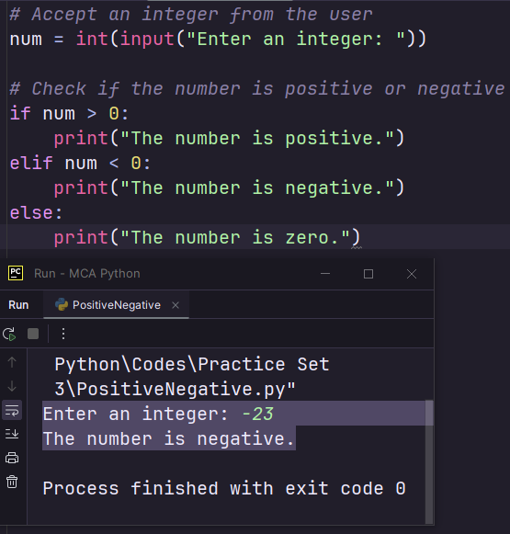

Ques-4 Write a program to Check if a given Integer is Odd or Even

Code:

# Accept an integer from the user  
num = int(input("Enter an integer: "))  
  
# Check if the number is odd or even  
if num % 2 == 0:  
 print("The number is even.")  
else:  
 print("The number is odd.")

Output:

Enter an integer: 23

The number is odd.

Snap:

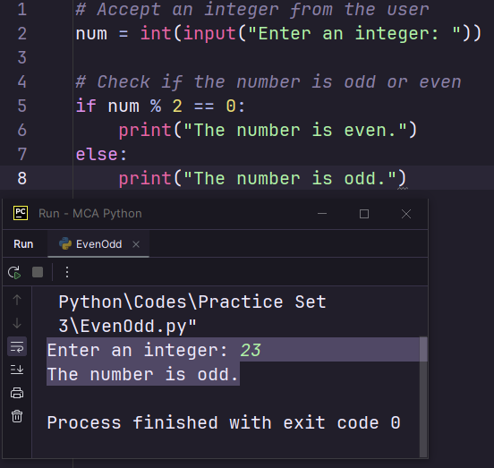

5. Write a program to Check if a given Integer is Divisible by 5 or not.

Code:

# Accept an integer from the user  
num = int(input("Enter an integer: "))  
  
# Check if the number is divisible by 5  
if num % 5 == 0:  
 print("The number is divisible by 5.")  
else:  
 print("The number is not divisible by 5.")

Output:

Enter an integer: 25

The number is divisible by 5.

Snap;

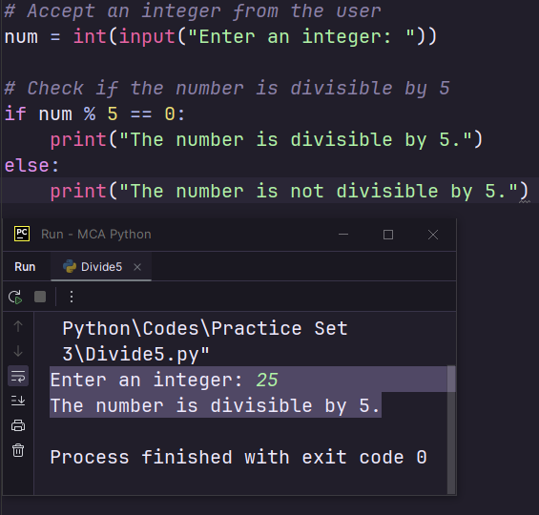

6. Write a program to Check if a given Integer is Divisible by 7 or not.

Code:

# Accept an integer from the user  
num = int(input("Enter an integer: "))  
  
# Check if the number is divisible by 7  
if num % 7 == 0:  
 print("The number is divisible by 7.")  
else:  
 print("The number is not divisible by 7.")

Ouput:

Enter an integer: 46

The number is not divisible by 7.

Snap:

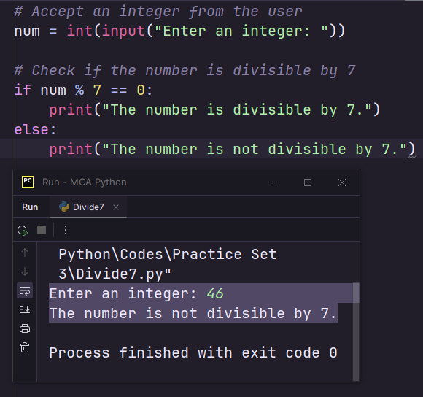

8. Write a program to find the greatest of three numbers using else if

ladder.

Code:

# Accept three integers from the user  
num1 = int(input("Enter the first number: "))  
num2 = int(input("Enter the second number: "))  
num3 = int(input("Enter the third number: "))  
  
# Find the greatest number using an else if ladder  
if num1 > num2 and num1 > num3:  
 greatest = num1  
elif num2 > num1 and num2 > num3:  
 greatest = num2  
else:  
 greatest = num3  
  
# Print the greatest number  
print("The greatest number is:", greatest)

Output:

Enter the first number: 23

Enter the second number: 35

Enter the third number: 22

The greatest number is: 35

Snap:

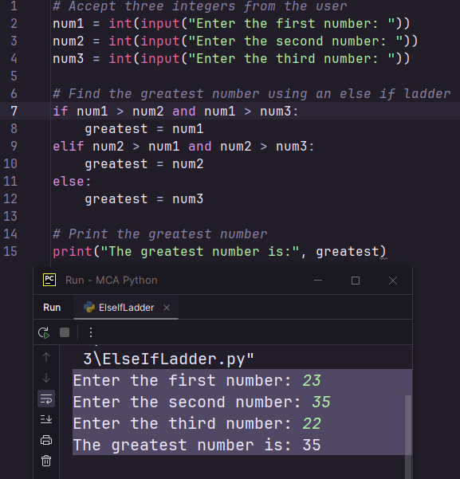

9. Write a program to find the greatest of three numbers using Nested if.

Code:

# Accept three integers from the user  
num1 = int(input("Enter the first number: "))  
num2 = int(input("Enter the second number: "))  
num3 = int(input("Enter the third number: "))  
  
# Find the greatest number using a nested if statement  
if num1 >= num2:  
 if num1 >= num3:  
 greatest = num1  
 else:  
 greatest = num3  
else:  
 if num2 >= num3:  
 greatest = num2  
 else:  
 greatest = num3  
  
# Print the greatest number  
print("The greatest number is:", greatest)

Output:

Enter the first number: 25

Enter the second number: 12

Enter the third number: 16

The greatest number is: 25

Snap:

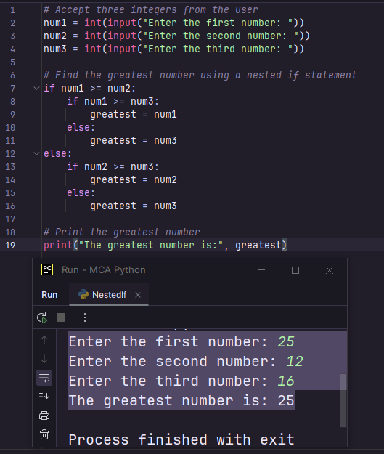

10. Write a program to convert an Upper case character into lower

case and vice-versa.

Code:

# Accept a character from the user  
char = input("Enter a character: ")  
  
# Convert the character to lowercase or uppercase depending on its case  
if char.islower():  
 new_char = char.upper()  
else:  
 new_char = char.lower()  
  
# Print the new character  
print("The new character is:", new_char)

Output:

Enter a character: RAHUL

The new character is: rahul

Snap:

